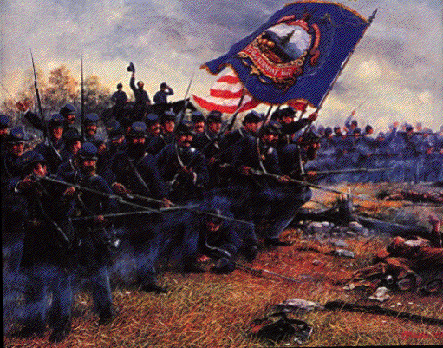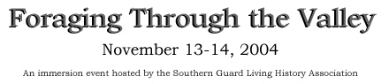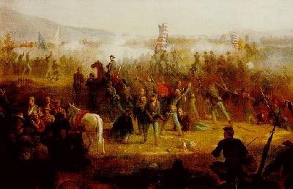
4th Vermont
VOLUNTEER INFANTRY

Introduction

It is October 1864. Federal troops moving through the Shenandoah Valley send details into the surrounding countryside to search for forage, contraband of war, and deserters. Company “A” of the veteran 4th Vermont infantry has been ordered to this duty. They plan to establish a temporary camp at the base of Mt. Jackson from which to mount patrols into the surrounding countryside and to be prepared for any contingency.

This November the rolling hills of the Piedmont will lend itself as a back drop for the Southern Guard Living History Association's Fall Picket post. Unlike past picket posts that have been in a fixed position, this event will be more of a march/patrol. The event will be 36 hours of first person starting with a ration and ammo issue and continuing with a 5 mile march, all night pickets and pure Civil War soldier life.

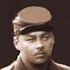
Private Eric Tipton
a biography

Where I Was Born:

I was born August 17, 1830 in Springfield, Ohio.

Family:

My family moved to Brattleboro, when I was four years old in 1834. My Father had the opportunity for work as a farmer. My mother Pamela helps with the farm. They both grew up in Springfield, Ohio.

My brother Ryan was born in 1832 and is an artist/writer living in Burlington, Vermont.

My Father’s side of the family is mostly located in Kentucky. My cousin Private George Tipton enlisted with the 2nd Kentucky Cavalry and was captured in March 1863. He re-enlisted with the 7th Kentucky Cavalry upon his release and fought with them until the end of the war. My other cousin Private Elijah Hull fights with the 40th Regiment Ohio Infantry Company “C”.

My Mother’s side of the family lived in Springfield, Ohio. Their name is Chamberlain. My Grandfather and Grandmother have passed away. My Great Grandparents (Jensen) came over from Norway and that is where I got the name Eric. My middle name – Arthur comes from my Grandfather on my Mother’s side.

Education:

I finished 12th Grade in Brattleboro.

Marriage:

I met my wife Alexandra Avenarius Sasha, a Russian immigrant in 1858. I was married July 17, 1859 to Sasha. We were married at my parent’s home in Brattleboro.

My Wife Alexandra:

Alexandra was born on May 3, 1838 in Moscow. She came to the United States in 1857. She works for the Dancy family in Brattleboro as their governess teaching the children Lauren, Megan and Abigail. She is paid $2.00 per week.

Career:

I am a teacher. I am paid $3.15 per week plus room and board.

Home

My wife and I live in one of the rooms of a boarding house in downtown Brattleboro.

Mustered in:

I Mustered into U.S. Service September 21, 1861 at Brattleboro. Three years.

Why Did I Decide to Fight?

My Father was in the military and fought in the Mexican War. He volunteered and served as a Lieutenant. I was too young at the time to volunteer. I was only sixteen and wanted to go to college.

I believe that slavery is wrong. I also am a patriot and I think we should preserve the Union. I admire the South for it’s stance on the rights of states within the Union, but I feel that the foundation of their argument is rooted in slavery and this in itself is morally wrong. My family is much divided on this issue because of my roots in Kentucky.

Money

- What cost $100 in 1850 would cost $2045.01 in 2001.
- Also, if you were to buy exactly the same products in 2001 and 1850,
they would cost you $100 and $4.89 respectively.
- Prices today are 20.45 times the amount back then.

BRATTLEBORO, VERMONT
Windham County
Brattleboro Population in 1860 was 3,855

Five Largest Towns in Vermont - 1860

Burlington 7,713
Rutland 7,577
Bennington 4,389
Northfield 4,329
Brattleboro 3,855

A Brief Historical Account of District No. 15.
[By one of the first pupils of the school.]
In the early days of this district, and previous to its organization, Dr. Cyrus Butterfield, who then lived where Warren Hescock now lives, Dea. Oliver Carpenter, who lived on the present Oliver Carpenter place, and Ezra Barrett, who lived on the place known as the Barnabas Fitch farm, united in thinking the distance too great for their children to attend school in the districts to which they belonged and decided to hire a teacher, each one to pay their proportionate part of the expense. They secured a room in the house on the corner known now as the Warren Hescock house, so recently taken down, then owned by the widow, Sally Butterfield, mother to the late Alanson Butterfield. The term of three months' school was taught by Miss Ruth Dunklee, then a young lady of 15 years. She proved a very successful teacher. Later she married Nelson Barbour, a Congregational minister, and although her work here closed long since, her memory is cherished by her pupils who survive her.

In a short time the district had applications from others to join them in school affairs, and by paying such a part of the expense as was required they were allowed to do so. In 1833 Alfred Harris, who lived where Chas. Harris now lives; Mr. Orvis, who lived where Henry Timson now lives; Alanson Butterfield, where Oscar Leonard now lives; Dr. Cyrus Butterfield, Dea. Oliver Carpenter and Ezra Barrett built a schoolhouse at their own expense. Dea. Carpenter gave the land and in the fall it was completed, ready for the winter term. It was not a modern style building, yet many there gained all the book knowledge they had, and going out into the world have been successful in business and useful in the society in which they moved.

In 1834 there were so many applications for attendance to this school that application was made to the selectmen of Brattleboro and Dummerston that the school be organized as a joint district. This petition was granted, and in the fall of 1834 district No. 15 was organized. The winter following there was a school of 25 scholars and 30 children in the district.

For some time the expenses of the school were paid by a tax and a tuition fee. Later as the farms changed hands others came into office and no tuition charged. For many years a tax of 70 cents on a dollar was raised to defray the expenses of eight months' school--four in the summer and four in the winter.

The winter of 1864 brought some adversity to this district, the old schoolhouse being destroyed by fire. It was in a dilapidated condition at the time it was burned, but it was needed, as the winter term of school was not completed. Oliver Carpenter then furnished rooms at his home so that the term might be finished. Before it was finished, however, his house was also destroyed by fire. The following fall, that of 1865, the present schoolhouse was built.

About this time the place now occupied by George Atkinson, formerly known as the John Alexander farm, and the E. C. Dunklee and A. W. Gage farms were annexed to the district by vote of the town. The united efforts of the district made the school a success for years.

Now another system has presented itself, taking the burdens of office and responsibility from the members of the district and placing them upon the town and its officers. Still there is the same liberal feeling of respect for teachers and scholars as when the district was in full responsibility. The scholars who now have the privilege of Miss McVeigh's instruction are bright and active, being much credit to all who are trying to fit them for lives of usefulness.
Source: Vermont Phoenix, January 6, 1899.
Wilkins Lilley's Billiard Saloon 1860

AN EPISODE.--A man calling himself "Dudley Kavanaugh the celebrated billiard player," got introduced to the "solid men" of this village, on Wednesday, and to our friend Lilley in particular, who threw open his Billiard Saloon, lager included, "free gratis for nothing" on the momentous occasion. During this time the way the balls chased each other over the table and cut up all sorts of astonishing antics couldn't be beat; even the Frenchman Berger, would have been astonished thereat. Unluckily for the reputation of this renowned Kavanaugh, Wilkes' Spirit made its appearance that evening at the counter of neighbor Carpenter with a "dogtype" of the veritable Kavanaugh which resembles his travelling namesake about as much as the moon resembles a "green cheese."--The "solid men" aforesaid voted unanimously that they were completely sold.

--It subsequently appeared that the name of this pseudo "Kavanaugh" was George T. Batterson of Hartford, Ct. Through the instrumentality of a friend he was led to indulge in the joke of personating the celebrated billiard player. He is intimately acquainted with Phelan, Kavanaugh, Chrystal, and other notorieties in the billiard line, and thus was able to pass successfully the criticism and cross questioning of our friend Lilley. But suspicions were all allayed, and Kavanaugh, alias Batterson was treated by his brother in the profession to an excellent dinner with all the necessary "fixins"; his bills were all paid and he was made a welcome guest. We imagine some of Batterson's Hartford friends will be regaled with a narrative of his adventures.

Wilkins Lilley's billiards were in the Jonas Cutler block on the lower Main Street hill on the east side.

Copperheads

There were in Brattleboro a few rebel sympathizers--"copperheads" as they were termed--who expressed satisfaction over the fall of Sumter, but they repented for such manifestations of disloyalty. The stories of how these "copperheads" were suddenly converted to the Union cause are amusing. With the announcement that the rebels had triumphed in their first attempt at arms it behooved the men of the north to take active steps to suppress any attempt of succor or support, and the men of Brattleboro lost no time in informing the most radical rebel sympathizers that the time had arrived to talk and act differently. The first demonstration of this kind in Brattleboro occurred at the home of George Bugbee who lived in the two-story brick house west of the present Grange block. Mr. Bugbee kept a boarding house and much of his time had been spent upon the street for several days previous to the receipt of the news from Charlestown. With the arrival of the news that Sumter had fallen Mr. Bugbee felt that his cause was in the ascendancy and he lost no opportunity to deride the north for its attitude toward the south. On the evening of Tuesday, April 16, Mr. Bugbee's neighbors made him a call and he was given a chance to repudiate the rebel cause. There are few survivors of that interesting occasion in Brattleboro and they smile as they tell how George changed his mind and espoused the Union cause suddenly after a half dozen stones were thrown through his bedroom window. He decided to retract when he saw the temper of the crowd and said that he was willing to espouse the Union cause. That simple statement was not sufficient. He was brought out doors and commanded to kneel down on the national flag and repeat an oath of allegiance administered by Captain Phelps who a few weeks later took command of the First Vermont volunteers.

There are other instances of sudden conversion of "copperheads" in Brattleboro, though the town authorities took steps the day following Mr. Bugbee's "admission to the Union" to prevent further demonstrations. They issued a statement that no citizen should be molested in his home but how religiously this mandate was carried out will be shown later.

With the announcement from the south that the rebels were in possession of Sumter came an outburst of sentiment against Jefferson Davis by the people of Brattleboro and the president of the Southern Confederacy was hung in effigy on a gibbet erected on Main street directly in front of the Brattleboro House. Not content with expressing their contempt for "Jeff" Davis and his cause by hanging him in effigy the stuffed figure was cut down and burned. John S. Tyler, C.A. Miles and Captain Todd were among the young men who helped convert local "copperheads."

In the unwritten history of Brattleboro in the War of the Rebellion should be mentioned James Lilly. "Jim," as he was familiarly known, was an ardent supporter of the Union cause. This West River farmer had seen pictures of flags but his color scheme was rather at variance with that used in the manufacture of the national colors. His was of yellow and white as he had no red cloth. The stripes of yellow were sewed upon a large sheet of white and the designer was liberal in his starry effect. With the announcement from the south that Sumter had been fired upon word came that one of Brattleboro's well-known summer guests, Harvey Bawtree, was to become a lieutenant in the Confederate army. Mr. Bawtree had spent his summers in town for several years and came from the south.

Source: Brattleboro Reformer, April 14, 1911, "Brattleboro's Spirit of 1861" extract.

Fine Record in Two Wars
Death of Major L. M. Grout, Vermont's Last Survivor of Mexican War
Quelled Mutiny at Brattleboro Camp

When the war of the Rebellion broke out, his military experience was remembered, and he was given charge of recruiting work. But he soon decided to go himself to the front. He had been drilling a body of volunteers, which later became Company A of the Eighth Vermont, and his men refused to organize unless he would accept the captaincy of the company.

Captain Grout spent the winter of 1861-1862 in camp with his regiment at Brattleboro, where his only protection from the cold was that afforded by a canvas tent. Part of the regiment, dissatisfied with their quarters in portable sheds, planned to leave the camp. On the very night when the plan was to be carried out, and within a few minutes of the time set, Captain Grout overheard a conversation which revealed the scheme to him. Hastening to a point where a sentry was stationed in a narrow passage cut through a snowdrift 12 feet deep, he relieved the soldier of his rifle and took the post himself.

"Go to the first lieutenant of my company," said the captain, "and tell him to bring the men here at once on the double quick." But before the company reached the spot the dissatisfied men, 600 strong, appeared. Captain Grout faced them. "Not a man passes," said he, "except over my dead body." A few thrusts of his bayonet held them back until the arrival of his men, when the rebellious volunteers were quickly driven back to their quarters, unarmed as they were.

Flat Street House - 1862

IN A PREDICAMENT.--Late on Saturday evening the police of this village were called upon to suppress a disturbance at a house of ill-repute on Flat-street, occasioned by some of the soldiers of the 8th Regiment. The police declined to interfere unless accompanied by some of the proper military authorities. Accordingly the information was laid before Col. Thomas who, with suitable guard, proceeded to the aforesaid establishment and there captured a gay Lieutenant and sundry privates. The captive officer was ordered to report himself under arrest and the privates were sent to the guard house. Two of the privates escaped with one of the women by secreting themselves in the cellar. It is currently reported that these arrests were made upon information given by certain civilians, who had been temporarily supplanted in the affections of the inmates of this house by the aforementioned soldiers.

Source: Vermont Phoenix, February 27, 1862

Vermont Timeline

1830
- The Vermont Central Railroad was established.
- The state's population was 280,652 with Middlebury as the largest city of 3,468 people.

1835
- Lamoille became the last Vermont county to be incorporated.
- The first anti-slavery party movement began in Vermont.

1836
- Originally the Vermont government was made up of a governor, lieutenant governor, Executive Council and a House of Representatives. In 1836, however, the Executive Council was abolished in favor of a Senate.

1837
- Vermont's US senators continued to denounce the practice of slavery, asking for its abolition in Washington, DC.

1838
- Imprisonment for debt was abolished.

1839
- The Anti-Slavery Party formed.
- The Burlington breakwater was constructed to protect Burlington harbor.

1840
- The state's population was 291,948 and Burlington was the largest city with 4,271 people. The male population exceeded the female by about 1,500.
- The number of people engaged in agriculture was 73,150. The major commodities were corn, with 1,119,678 bushels; barley, with 2,222,584 bushels; hay, with 8,869,451 bushels; silk in cocoons, with 4,647,934 pounds; and dairy products were valued at $2,008,737.
- Vermont was ranked second among all states for the production of wool. There were 1,681,819 sheep in the state producing 3,699,235 pounds of wool. There were 334 wool factories with a value of $1,331,953.
- Addison County was said to have more sheep than any other US county. Shoreham alone has 41,188 sheep producing 95,276 pounds of wool.
- The total value of Vermont manufacturers was $6,923,982. Ten percent of Vermont's manufactured goods were made in the home compared to a national average of 6 percent of goods manufactured at home. Factories were still very small in Vermont and often were powered by waterfalls nearby.
- A wage of $8 a month plus room and board was considered reasonable for a farm hand. Occasionally during the harvest or haying season, $1 a day would be paid for extra help.
- There were 2,300 district schools with 106,000 children ages 4-12. The aggregate expenses for schools was $292,730 a year, or $127 for each school district.

1845
- The first postage stamps made in the United States were printed in Brattleboro by Postmaster Palmer. They were printed in black ink on a light buff paper.

1846
- The Estey Organ Company of Brattleboro was established.

1847
- A telegraph line opened between Troy, NY, and Burlington. It was expanded to Montreal, Boston, and White River Junction in the next year.
- Since Vermont was admitted to the union in 1791, 310 patents had been issued up to this year. Only nine of the 29 states exceeded this number.

1848
- On June 26, the first passenger train in Vermont passed over the rail lines from White River Junction to Bethel. It was a Vermont Central train.

1850
- The state's population was 314,120 with Burlington as the largest city, having 7,585 people. The census reported that there were 718 persons in Vermont.
- There were 29,763 farms with a total value of $78,749,737. The average value of land per acre was $19.09, and there were 2,601,409 acres of improved land versus 1,524,413 acres of unimproved land.
- The major crops were corn (2,032,396 bushels), oats (2,307,734 bushels), and potatoes (4,951,017); 866,153 tons of hay were produced.
- There were 1,014,122 sheep in Vermont producing 3,400,717 pounds of wool.
- 12,137,980 pounds of butter were produced, and 8,729,834 pounds of cheese.
- State manufacturers had $5,001,377 of invested capital, goods were valued at $8,570,920, and manufacturing employed 8,445 people.
- There were 72 woolen mills employing 1,393 and with an output valued at $1,579,161.
- There were nine cotton mills employing 241 people and with an output valued at $280,300.
- There were 36 newspapers, with two of them being dailies and 15 of a literary quality. The rest were weeklies.
- Vermont had 96 private libraries with 64,641 volumes and 30 public libraries with 21,061 volumes.
- The average monthly wage of a farmhand was $13. An average laborer was paid 72 cents daily with room and board and 97 cents daily without room and board.
- The average wage for a teacher was $3.15 per week plus room and board. A total of $217,402.33 was spent on schools.

1860
- The state's population was 315,098, an increase of only 978. The census results were disputed by many. Burlington's population was recorded as that of the largest town in Vermont, with 7,713 persons. Windsor, however, was the most populous county with 37,193 persons.
- Rutland County ranked first in industry with 336 manufacturing establishments.
- There were 752,201 sheep in the state yielding 3,118,950 pounds of wool.

1861
- On April 12, Fort Sumter in Charleston Harbor was attacked by Confederate forces and war began. The state militia was mobilized. Patriotic fervor in Vermont was high to put down the rebellion. Six new regiments were to be raised, far in excess of President Lincoln's request.
- The volunteer companies were arranged by town. By war's end, whole companies had been devastated, and therefore so had the male population of a town and county.

1862
- The current Vermont state coat of arms was adopted. A green landscape covers half of the shield with blue mountains in the background against a yellow sky. A pine tree stands near the base and reaches nearly to the top of the shield in a natural color. Three sheaves of yellow grain and a red cow were on the left hand side. The crest was a buck's head and a scroll draped below reads "Vermont -- Freedom and Unity." The state flag at the time had 13 red and white stripes on it.
- The state appropriated $750,000 for military costs.
- Vermont soldiers refused to return captured slaves to their masters in any state.

1863
- Vermont had in service: 16 infantry regiments; 1 cavalry regiment; 3 companies of sharpshooters; 2 batteries of light artillery. A total of 18,224 men. These men were paid $7 a month by the state.
- July 1-4, The Battle of Gettysburg. The New York Times said after the battle: "A Vermont Brigade held the key of the position at Gettysburg and did more than any other body of men to gain the triumph which decided the fate of the rebellion."

1864
- Burlington was incorporated, after being rejected in 1852, as the second city in the state. Vergennes was the first in 1788.
- There were 4,216 patients in Vermont hospitals as of October 1. Most of them were soldiers sent home for treatment. The Civil War created a medical disaster never truly equaled in US history. Everywhere could be seen men without arms and legs, many of whom were just barely clinging to life.
- On Wednesday, October 19, at 3 pm, Confederate raiders attacked St Albans, robbing the St. Alban's, 1st National, and Franklin County banks. They escaped with $200,000. A posse was created to catch them, but they got away to Canada. Thirteen of the raiders were later caught and held in jails in Canada. The raid caused widespread panic in Vermont and the nation as it was the most northern Confederate assault.

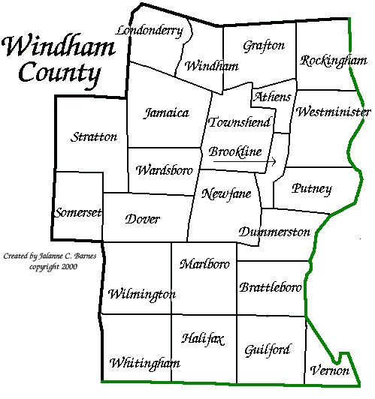
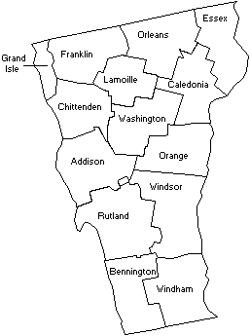
Vermont State Map
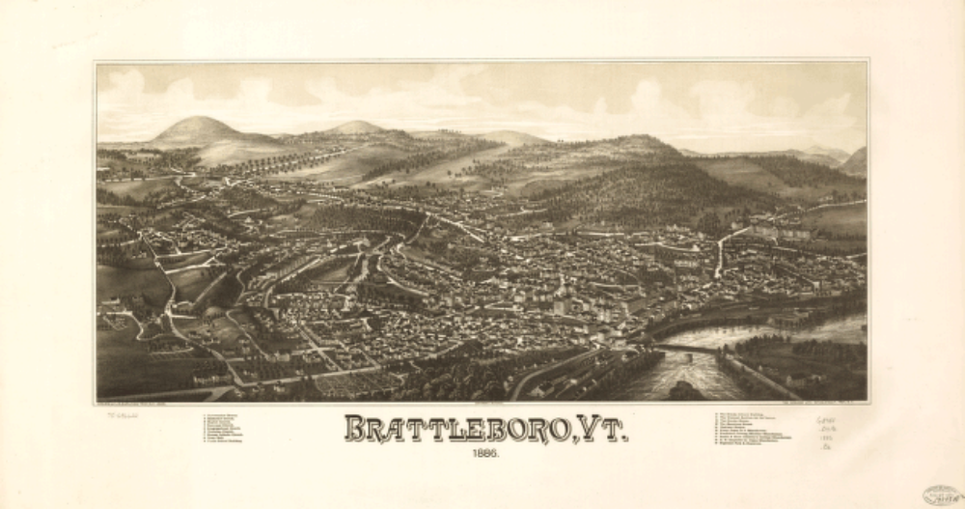
The French and Indian Wars prevented settlement of the original grant, and Benning Wentworth renewed the charter in 1760 and 1761. Originally Brattleborough, the town was named for the first grantee, Colonel William Brattle, Jr. of Boston, listed as a clerk in earlier records, later a member of the colonial militia. He is not known to have ever visited the town named after him, except perhaps to have become familiar with the area during various military forays through the area prior to the grant.
Throughout the remainder of the 18th century, the town's population grew and flourished. A gristmill and sawmill were built on Whetstone Brook. A post office opened in 1784 at the Arms Tavern, the current site of the Retreat Farm. Because the town was on a stage coach route, the economy benefited from the trade of grain, lumber, turpentine, tallow and pork. Industry and commerce thrived during the 1800s as well. The Vermont Valley railroad ran directly through town, providing a vital link north.
It was in 1888 that Postal authorities decided that all towns ending with -borough should be shortened to -boro. Vermont went along with it.
In the 1840s, Brattleboro developed a reputation as a resort town. Pure springs were discovered along the Whetstone Brook. The Brattleboro Hydropathic Establishment, more commonly known as "The Water Cure", opened in 1846. Wealthy patrons came from all over the world for treatments which included plunges in the cold springs, long walks in the woods and healthful food, sans alcohol or tobacco. The Water Cure operated until 1871.
Overland Transportation- Post Roads, Turnpikes, Stage Roads, Market Roads (1780-1940)
The earliest roads in what was to become Vermont were cleared along Indian trails and well-defined topographic corridors such as river valleys, mountain passes and hilltop routes connecting early settlements. Military roads were among the first roads constructed. Gradually, newly settled towns began building local roads and bridges. Post roads, over which riders delivered mail, were first constructed in the 1780s under the direction of the General Assembly. By the beginning of the 19th century, a "turnpike craze" had developed. These privately owned toll roads were somewhat better than the locally constructed roads, and greatly increased the overland transportation network. Stage coach lines were organized as soon as the turnpikes were constructed. The stage coach business was in its heyday from 1820-1830, and taverns and inns often served as the stage coach "stations." Many villages grew up at the intersection of major routes, and small neighborhoods developed at the intersections of less-travelled routes. By the middle of the 19th century most turnpikes had been transferred to town ownership, and the coming of the railroad replaced many former stage roads as the primary mail, passenger and freight routes. However, with the arrival of the automobile in the early 20th century Vermont's road system underwent significant improvements and became the focus, once again, of commerce and transportation.
Military Roads: (1759-1781)
Military roads were the first long distance routes of land travel in what was to become Vermont. They are significant both as military highways and as subsequent routes of settlement. The first was the Crown Point Military Road, built by the English during the French and Indian War. Constructed in 1759-60, the road provided the English with a means of land transportation over the Green Mountains between their northernmost fort on the Connecticut River in Charlestown, N.H. and the garrison at Crown Point on Lake Champlain. The second was the Mount Independence-Hubbardton Military Road which was constructed during the American Revolution. It was built in 1776 by the American Army and ran from Mount Independence in Orwell to make the connection with the Crown Point Road at Rutland Falls. The Bayley-Hazen Mililtary Road was also constructed during the American Revolution. Built between 1776-79, it was conceived as an aid to invade Canada by means of an unoccupied and more direct route than the British-controlled Champlain Valley. The road as completed stretched 54 miles over mostly high ground from Wells River to Hazen's Notch. In the course of building these early military roads, blockhouses and forts were built with relative frequency. Stone mile markers were also placed along each of the routes, and major camps were set up at regular intervals. Today, most of these sites remain as potentially valuable archeological sites.
Water Transportation and Commerce: (1790-1940)
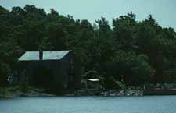
Larrabee's Point, Vermont
Vermont's water routes were first used by Native American people as early as 10,500 B.C. when Lake Champlain was still a saltwater sea. With the rapid settlement of the Champlain Valley at the close of the American Revolution the lake became a dominant corridor for transportation and market shipments north to Canada. The Connecticut River was also a major corridor early on to points south, carrying lumber rafts, and flatboats weighted with cargo to New Hampshire and Massachussetts. After the construction of the Bellows Falls (1802) and Champlain (1823) Canals, and the advent of steam-powered boats during the first decade of the 19th century, both water routes bustled with passenger and freight carriers. A number of ports along the Vermont shores of Lake Champlain developed into busy centers of commerce and shipbuilding, and storage depots, shipyards, mills, taverns and hotels were built to accommodate the various kinds of traffic. After 1850 the railroad eclipsed these water corridors as the major transportation routes. By the late 19th century lake commerce had largely given way to pleasure boating and commuter traffic.
Railroads: (1830-1940)
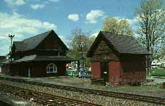
South Royalton, Vermont
Although Vermont railroad companies were being chartered as early as 1832, it was not until 1848 that the first tracks were opened by the Vermont Central Railroad from White River to Bethel. By 1855 over 500 miles of track had been constructed. Prior to the Civil War the basic north-south spines of the Vermont railroad network were completed. Railroad construction ceased during the Civil War, then started up again in the 1870s with the construction of east-west lines linking the major routes. At the close of the 19th century Vermont had approximately 1,000 miles of steam rails, and 75 miles of electric rails. Every county had one or more railroads, and of 248 towns and cities in Vermont less than 100 were without rails. The railroad brought dramatic changes to the Vermont landscape. It created new towns, prompted the decline of others, and stimulated the development of key industries such as dairying, stone quarrying, and tourism. The advent of the automobile in the early 20th century eclipsed the role of the railroad, though it continues to be used for freight and limited passenger service to this day.
THE ST. ALBANS RAID
October 19, 1864
Twenty cavalrymen, organized by Confederate agent George Sanders and led by Lieutenant Bennett Young, swooped down out of Canada and took over St. Albans, Vermont in what was to go down in history as the northernmost engagement of the Civil War. With his gun drawn, Young mounted the steps of a hotel and shouted: "This city is now in the possession of the Confederate States of America."
The battlefields of the Civil War suddenly didn't seem so far from this village about 15 miles south of the Canadian border. Shock and confusion followed as gun-toting horsemen galloped down Main Street, herding terror-stricken townfolk onto the Village Green.
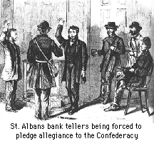
The raiders then turned their attention to robbing the three local banks. Even though the Confederates dropped much of their loot in the confusion of escape, they still managed to make off with over $200,000. By the time residents could organize a pursuit, the marauders were well on their way back to the border.
As they left, they tried to burn down the town, but managed to destroy only a woodshed. They had evidently planned to burn the mansion of Governor J. Gregory Smith, who was in Montpelier at the time. Soon after the raid began, a maid from a neighbor's house rushed to Mrs. Smith, crying: "Rebels are in the town, robbing the banks, burning the houses, and killing people. They are on the way up the hill to burn your house!"

Mrs. Smith drew the shades and bolted the doors, all but the front entrance. Her first impulse had been to run up the flag. Instead looking for weapons, she found only a large horse pistol, but no ammunition. With this in hand she took her stand in front of the house. She could hear a horse galloping up the hill; it turned out to be not one of the raiders, but her brother-in-law, a member of General Custer's staff, home on leave. Later that night, soldiers were stationed at the governor's house.
One of the raiders was wounded and died shortly thereafter. The survivors were arrested in Montreal and tried, but never extradited despite energetic efforts by Washington. Lieutenant Young rose to the rank of General. When he again visited Montreal in 1911, a group of St. Albans dignitaries paid him a courtesy call at the Ritz-Carlton Hotel.
Two years later, an international incident was narrowly avoided when a guerrilla force of several hundred Fenians (perhaps as many as 3,500) poured off special trains from Boston, determined to liberate Canada from the British and establish an Irish Free State.
After camping out on the village green, they marched north until they were about six miles over the border, having crossed into Frelighsburg, Quebec from Franklin, Vermont. The Canadians declared Martial Law and President Johnson ordered munitions and supplies left in St. Albans seized under the Neutrality Act of 1818. When the Fenians retreated to St. Albans, where they found the park occupied by U.S. troops sent there by President Johnson to enforce neutrality. Defeated without so much as a single shot fired, the Irishmen were escorted to the depot and shipped back to Boston while locals were entertained by an Army band concert.
http://www.virtualvermont.com/history/staraid.html
Here's something regarding the Raid on St. Albans, Vermont from "A War of the People: Vermont Civil War Letters", editor Jeffrey D. Marshall. p.p. 277-279. The letter is from Ben Dewey of Waterbury to Colonel William Wells of the First Vermont Cavalry, November 5, 1864
Waterbury, Vermont
November 5th 1864
Dear Col.
Your favor of the 26th ult came o hand last evening and I was right glad to hear from you and that you are safe and well... Presume you have heard of the raid on St. Albans. It was a rough affair - and undoubttedly it is not the last of its kind - The towns in the northern part of the state are armed, and in fact, generally the towns are taking measures to protect themselves - Our town has started a company and we are daily expecting our arms - Revolvers have been in good demand, and a great many are carried here - The State is full of strangers prowling around with no apparent business, some arrests have been made - was told this morning that in St. Johnsbury a man was arrested who had letters upon his person by which they learned it was contemplated to pitch in there. A lot of arms passed through here this morning for Morrisville Hyde Park and Johnson-
I want you to seize for me, a Spencer rifle. Confiscate and bring it home to me - Do not know that any of the hounds have made me a visit yet though on the day of the St Albans raid I had a suspicious customer - who was visiting banks for the purpose of teaching them to detect counterfeit money I dident see it, and consequently he remained on the other side of the counter. Hoping that we shall see you home soon and that, (as) a Brig Genl! I remain in haste,
Fraternally Ben H. Dewey
An Abstract on the Underground Railroad in the County:
But even of greater importance than the work that was done through the west part of the State was that of the "underground railway" that ran up the Connecticut Valley with regular stations at Hartford, Northampton, Greenfield, Brattleboro, Bellows Falls, Windsor and so on to Canada. The Brattleboro station was the home of the late Chas C Frost "the learned shoemaker" on Flat street, just opposite where the Carpenter Organ factory now is. Mr Frost with the earnest inflexible character that marked him through life, was an uncompromising abolitionist, and believed, without shadow of doubt, that he was doing God's work in helping runaway slaves to their freedom.
His son, Merchant Wells S Frost, says that in four or five years of this work not less than 40 or 50 negroes stopped at his father's house, and there was a room up stairs with bed and everything else necessary, constantly kept for them. They always traveled in the night time, would reach this house early in the morning with a letter from the man of the station at Greenfield and keeping in hiding in the room through the day time would start after dark for Bellows Falls with a sufficient supply of food and money and a letter to the man who had the station there. Wells Frost as a lad used to take their meals to them in the chamber and tells of one night finding the bed, chairs and everything else piled against the door. They were almost always in a state of utter fright expecting pursuers and recapture. Mr Frost now has in his store a slave driver's whip which one of them brought away from the plantation and presented to him. But never was one of them caught here and indeed very few people in town had any suspicion of the work the "learned shoemaker" was carrying on.
Source: "Local History" column, Brattleboro Reformer, 4-18-1899.
Jeff started off this thread concerning civilian occupations of soldiers from the 12th VT. The majority are shown to be farmers. Below is some insights regarding farming that I have gathered from A War of the People: Vermont Civil War Letters edited by Jeffrey Marshall and The Expansion of Everyday Life 1860-1876 by Daniel E. Sutherland. First excerpt comes from The Expansion of Everyday Life p.p. 132-135:
The money to buy land, livestock, tools, and all the other things people required to work a farm seemed out of reach to many people. Between $500 and $750 was thought necessary to purchase and operate a twenty to thirty acre farm in most parts of the country. Many people acquired the needed capital by working for wages as farmhands or at jobs in town...Henry K. Dey, who owned a 150-acre farm in Seneca County, New York, might be considered a typical northern farmer. Dey and nearly all his neighbors raised grains, mostly wheat but with some oats, barley, corn, and rye, as their chief cash crops. They supplemented grains with potatoes, apples, hay, butter, beef, pork, hides, and lumber. Part of Dey's profits paid the wages of a hired man and hired woman.
For $75 plus board, the hired man plowed, harrowed, harvested, split wood, hauled manure, and built fences...Dey and his hired hand worked 14 - 15 hour days...The hardest work on any northern farm came during planting and harvesting months: April through October. Planting began for Henry Dey with plowing, rolling, pulling up stumps, burning refuse, and generally preparing the fields for sowing...He harvested his earliest crops - hay and wheat beginning in July...Wheat had to be shucked and stored. Barley and rye had to be mowed, usually by hand...However, cutting and binding wheat proved the toughest test of all. Wheat harvest came in the hottest and driest part of the summer.
From a War of the People: Vermont Civil War Letters, p.p. 154-155
Asahel Hubbard of Whiting to his brother, Frank, Second Vermont Light Artillery, May 24, 1863
Brother Frank,
I will tell you about my good luck yesterday...Well in the course of the day the income tax collector called on me for my list of income for the past year which I have to pay a per cent tax for Government expenses. Note 2
2. The federal income tax of 3 per cent, passed by Congress as a war measure in 1861, was imposed on those who earned more than $800 annually...Vermont did not impose an income tax, relying instead on huge increases in the statewide property tax to pay for its war expenses.
Oh! Frank what will you think when I told you I sold the old oxen last Thursday for $175. they are so big and heavy I could not do much with them on plowed ground. I expect to get another before haying.
Source: From Mark Susnis on an Authentic Campaigner Thread
4th Vermont Volunteer Infantry

On September 25, 1862, the 12th Vermont departed for training at Camp Lincoln, located at Brattleboro, Vermont. The strength of the regiment was listed as 1,022. According to their enlistment papers, their pre-war occupations were as follows:
Farmers: 657 men
Mechanics: 66 men
blacksmith: 15 men
Misc. occupations included doctor, lawyer, laborer, mason, and newspaper editor.
Average age was 25. Youngest was 16 years of age; oldest being 59.

From p.p. 156-157 of "Full Duty"
A memorable battle, in which nobody on either side was killed took place in February when the new regiment in the Old Bde, the 26th NJ challenged the 3rd and 4th VT to a snowball fight. The 26th was a big regiment, numbering as many men as both VT units so the battle was about even at least in numbers. Combat was set for Feb 25th and a huge crowd of soldiers lined the field. The men were put into line of battle by their officers, skirmishers were advanced, and the fighting began. The Vermonters, as was their custom went in hard. These farm boys had grown up flinging snowballs on school playgrounds, and the fight was over rather quickly. The two Vermont regiments even captured the colonel, adjutant, and QM of the NJ regiment and their horses.
The NJ men also were bested in another way during the winter encampment. The 2nd VT had been experiencing an annoying and continuous loss of fresh meat from its regtl store. Some of the men came to believe that the meat was being taken by members of the 26th NJ. One night Vermonters crept into the NJ camp and pilfered the commander's pet Newfoundland dog. When they returned to camp, the dog was slaughtered and dressed, then hung in the tent of the 2nd VT QMs store. That night the carcass disappeared and the thieves' tracks were followed to the NJ camp. The VT soldiers figured that dog meat was henceforth on the NJ menu, perhaps on the regtl cdrs' table. The story quickly spread through the ranks of the AoP, and for a time the NJ men were greeted with woofs and bow-wows.
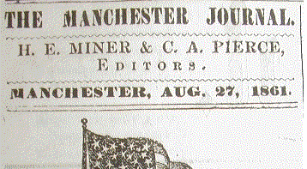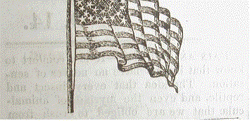

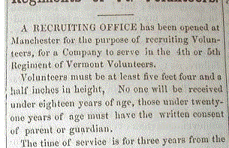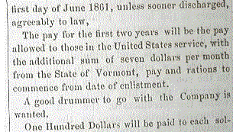

Corps Badges
The 4th Vermont was part of the Second Division of the Sixth Corps. The corps badge designated for this division was a white cross. As there are a number of photos of 4th Vermonters wearing badges and some images of Vermont Brigade members even indicate they wore badges on their cap and jacket at the same time.
In April of 1863, thousands of die cut cloth corps badges were issued to all troops in the Army of the Potomac. A supplementary issue was made in July. Thereafter badges were available from quartermasters, however, it appears from the evidence that in the later war period most soldiers bought their own insignia (usually metallic) from mail order firms or regimental sutlers.
Early regulations directed that badges were to be worn on the front or top of the cap, or on the side of broad brimmed hats. From period photos we can see that either these orders were ignored by some who chose to wear them on their breast or the orders were superseded to wear them on the front of the coats. Regardless, there are photos of Sixth Corps men with the badge in both places.
In 1863 the Sixth Corps badge usually was worn vertically like a "t" or a Greek Cross. On April 19 1864, headquarters ordered that henceforth the badge would be worn diagonally like an "X" or a Saint Andrew's Cross. Perhaps this was done to prevent confusion between the Sixth Corps badge and the Eighteenth Corps Badge who wore a similar cross.
If you choose to wear a corps badge, please cut them to be 1.5 inches wide/high to achieve the issue look and remember to wear it diagonally. Try to use a heavy all natural white cloth such as a heavy wool or felt.
History of the 4th Vermont
The First Vermont Brigade
Except for a brief period, the 1st Vermont Brigade, unlike most Federal brigades, throughout the war consisted of regiments from the same state. Two of these regiments, the 2nd and 3rd Vermont, formed part of Vermonter General William F. (Baldy) Smith's brigade in August 1861. When his brigade became a division that October, the 2nd and 3rd joined the new 4th, 5th, and 6th Vermont regiments and the 1st Vermont brigade. [2nd Brigade, 2nd Division, VI Corps.] In may of 1864 the 1st Vermont Heavy Artillery was assigned to reinforce the Brigade. One non-Vermont unit, the 26th New Jersey, also served with it from October 1862 to June 1863.
Throughout it's long service, the unit had three official commanders: Smith from August to October 1861, General William T.H. Brooks from October 1861 to October 1862, and General Lewis A. Grant from January 1864 to June 1865. Between these commands numerous regimental colonels assumed command of the brigade.
It's combat debut at Lee's Mill was inauspicious, as just 12 of the unit's 50 companies advanced piecemeal in brave, but unsupported probes. Brook's troops gained greater distinction at Savage's Station, White Oak Swamp and Crampton's Gap, and Chancellorsville.
Being a native New Yorker, I am personally fond of the Vermont Brigade's work in New York from August to September 1863 suppressing the New York City Draft Riots. They returned to the Army of the Potomac in time to support the victory at Rappahannock Station.
During 1864 the unit battled at the Wilderness, Spotsylvania, Cold Harbor, and First Weldon Railroad. When the brigade rushed north to save Washington, some of it's troops skirmished with General Jubal A. Early's troops before Fort Stevens. The 1st Vermont subsequently helped defeat him at Third Winchester, Fisher's Hill, and Cedar Creek.
Again returning to the army in December 1864, the Vermonters spearheaded the onslaught that finally overran Petersburg's defenses on April 2, 1865. Lewis Grant's men also harried General Mahone's final line at Sayler's Creek. After occupying Southside Virginia that spring, the brigade participated in the Grand Review on June 8, 1865. It was mustered out on June 28, and it's infantry units were mustered out in July. Co. F, 4th Vermont Volunteers
The main reason for selecting the 4th Vermont as a unit designation is the overwhelming amount of photographic evidence left behind by Vermont photographer G.H. Houghton. These photographs (over 100) document the 4th Vermont's experiences from Spring of 1862 to their homecoming in Battleboro, Vermont in July of 1865. These photographs are now in the Vermont Historical Society. Because of printing costs we cannot reproduce these photographs; however, they can be found in Images of War: Volume 6. Most local public libraries have this book. Charles Ross' Diary
The following paragraphs will deal with the history of the 4th. I have compiled three or four little incidents of their experiences to give you a better understanding of what these men experienced in the army. I hope this will serve you better than just a list of names and dates.
Below are some excerpts from Charles Ross's wartime diary. He was a member of the 4th Vermont and served with Company F. Ross spent his 25th, 26th and 27th birthdays while in the service of the army. He served with Company F in many battles and was captured and sent to Andersonville. He survived, unlike most of Company F; they started out with over 100 and at muster out numbered less than 20.
Enlisting
Raising of Company F, took place in Battleboro, where Ross who was a lifelong resident became one of its first recruits. Ross' diary explains some of the experiences of his early training in his hometown: "Our camp has been inspected today. Some have been thrown out. What my lot is I do not know. I rave received a greatcoat, blanket, kanteen & blowse from the Government also some shivering for my coat. I wish I could get in some place as I am not where I wish I could be....I do not like the way I am tented. I would like to be in a tent with my own chosen comrades. I am feeling pretty mean and have the wild-axe-handles, but I hope to get over it soon. I am pretty tired. We have drilled well all day." Ross writes the next week: "I am 24 years old to day another birthday I fear I never shall see." The 4th's First Casualties
As it rained ceaselessly throughout the first month's training for the regiment. 300 of the 1,054 men mustered into the 4th Vermont were unable to leave for Washington in September due to illness. Colonel Peter Washburn, who later would lead the brigade at Big Bethel, declined colonelcy of the Fourth due to his own illness.
The commission went to Edwin H. Stroughton of Bellows Falls, 23, just two years out of West Point. His 19 year old brother, Charles, was appointed Major. The siblings and the new regiment left Battleboro by rail on September 21, 1861, to the seat of war. The unit spent their first winter at Camp Griffen in Virginia. A Vermont private described the average day spent by the unit that winter: "At 5 o'clock in the morning comes the roll call, when each man trembles unceremoniously out of bed to answer his name, then comes out breakfast...at 7 o'clock is the knapsack drill...it tends to develop our muscles and learns us to endure hardships..at 10 skirmish drill and at 12 dinner. The intervals between drill and dinner are spent oiling and cleaning our guns. In the afternoon, half past one is the brigade drill, which lasts all afternoon, and at sundown is the dress parade, then supper. We receive our letters in the evening.. at 8 is the last roll call and we prepare to sleep until taps at 8:30 and the camp is still."
Baptism of Fire
At Lee's Mills, the 4th's first engagement, Colonel Stroughton was ordered to send four companies across the Lee's Mills dam to storm a one-gun battery on the opposite shore. With fixed bayonets the Vermonters went forward and were met by a furious fire and driven back to the cover of the woods. Stroughton won the love of his men during this fight as he personally carried the wounded to safety. Rumors spread after the battle through the 4th's ranks that 'Baldy' Smith was drunk. Regardless of these accusations he praised his men by saying: "Among the companies who crossed the creek, there were more individual acts of heroism than I ever read of in a great battle."
The New Colonel's First Battle
In February 1863 Charles Stroughton received his commission from the state of Vermont and became Colonel of the 4th, while his brother became Brigadier General of the newly formed 2nd Vermont Brigade. Latter that month a memorable battle that claimed zero casualties. The nine monthers of the 26th New Jersey challenged the 4th Vermont to a snowball fight. While the new unit outnumbered the Green Mountain boys the Vermonters agreed and set February 25 for the combat. The Field and Staff of both regiments formed their men into two ranks, advanced skirmishers, and began the fight. The Vermonters were successful, even capturing the New Jersey unit's colonel, adjutant, and quartermaster along with their horses.
A Holiday in New York
After Gettysburg the 4th was sent to New York City in response to the Conscription Riots, where they demonstrated to the New Yorkers what a veteran regiment looked like. When the ferry reached Manhattan Island, Governor Horatio Seymour offered to clothe the troops in new dress coats and trousers. Much to the surprise of the politician the men declined stating that they would gladly accept the gift on their way out of New York State. Thus, well drilled, ragged troops with torn and tattered clothes and bright muskets marched into Washington Square Park. Their disheveled presence, coupled with their discipline, acted as a psychological weapon. It worked, the rioters would not fight these veterans like they had their militia counterparts.
While in New York the Vermonters tore down the doors of saloons claiming that rioters were meeting there. After bludgeoning the owners, they consumed the building's contents. For three months the 4th was on holiday, doing whatever they wished all in the name of suppressing the draft riot.
One young Vermonter did not have such a pleasant stay in the Excelsior State. One evening, while leaning on his musket guarding the camp, a rioter "crept up slyly and pulled the trigger, discharging the musket and shattering his hand for life."

4th Vermont Images
Here are a few enlisted images of 4th Vermonters. For more enlisted and officer pics, click here: http://www.vermontcivilwar.org/italo/4.shtml

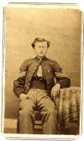  Lt. George P. Spaulding  Company B, 4th VT | 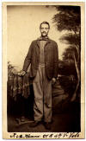  Private James Newton  Company B, 4th VT | 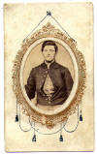  Private Martin V.B. Sleeper  Company B, 4th VT
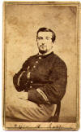  Private William H. Rahue  Company D, 4th VT | 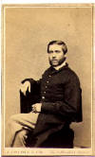  Private Theodore H. Hall  Company E, 4th VT | 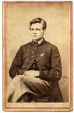  Private Charles O. Davidson  Comany G, 4th VT
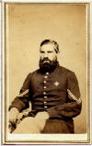  Corporal Lorenzo Harris  Company I, 4th VT | 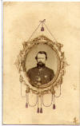  Private Isreal Stowe, Jr  Company I, 4th VT | 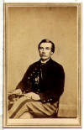  Sergeant Robert J. Coffey  Company K, 4th VT

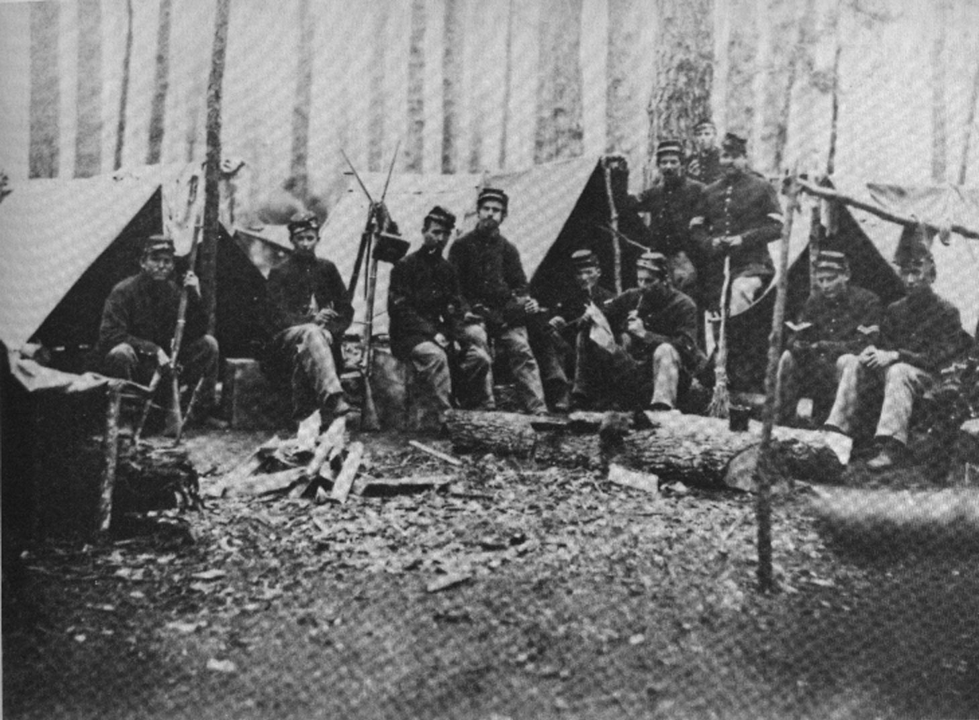

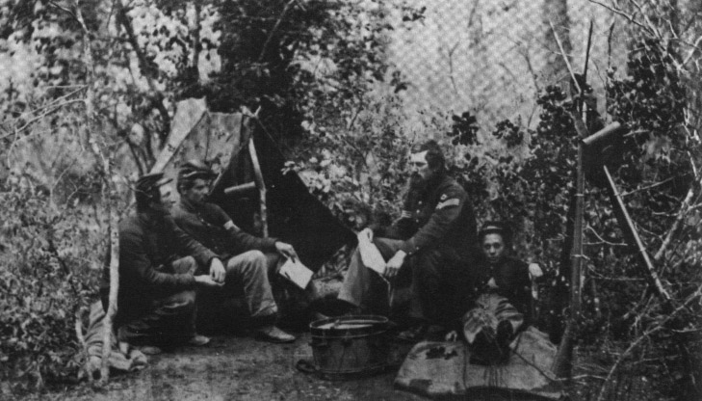

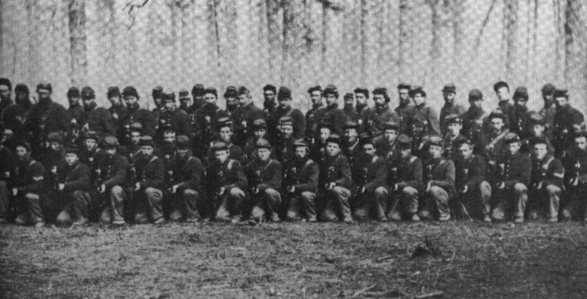

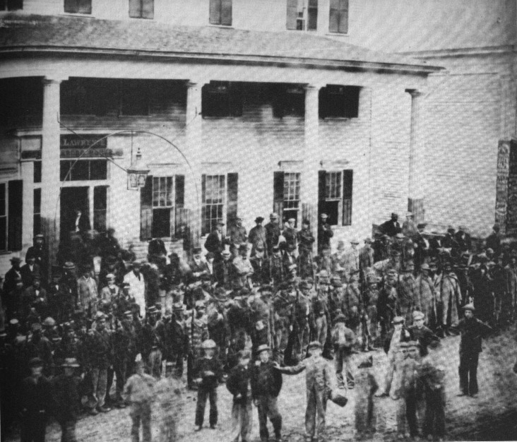

4th vermont - Record of Service
Organized at Brattleboro and mustered in September 21, 1861. Moved to Washington, D.C., September 21-23. Attached to Brook's Brigade, Smith's Division, Army of the Potomac, to March, 1862. 2nd Brigade, 2nd Division, 4th Army Corps, Army of the Potomac, to May, 1862. 2nd Brigade, 2nd Division, 6th Army Corps, Army of the Potomac, and Army of the Shenandoah, Middle Military Division, to July, 1865.
- Duty at Camp Griffin Defences of Washington until March 10, 1862.
- Reconnoissance to Vienna, Va., October 19, 1861.
- Moved to Alexandria March 10, 1862, thence to Fortress Monroe March 23-24.
- Reconnoissance to Big Bethel March 27-28. Reconnoissance to Warwick March 30.
- Young's Mills April 4.
- Siege of Yorktown April 5-May 4.
- Lee's Mills April 16.
- Battle of Williamsburg May 5.
- Seven days before Richmond June 25-July 1.
- Garnett's Farm June 27.
- Savage Station June 29.
- White Oak Swamp Bridge June 30.
- Malvern Hill July 1.
- At Harrison's Landing until August 16.
- Moved to Fortress Monroe, thence to Alexandria August 16-24.
- Maryland Campaign September-October. Crampton's Pass, Md., September 14. Battle of Antietam September 16-17. At Hagerstown, Md., September 26-October 29.
- Movement to Falmouth October 29-November 19.
- Battle of Fredericksburg December 12-15.
- Burnside's Second Campaign, "Mud March," January 20-24,1863.
- Chancellorsville Campaign April 27-May 6.
- Operations at Franklin's Crossing April 29-May 2.
- Maryes Heights. Fredericksburg, May 3.
- Salem Heights May 3-4.
- Banks' Ford May 4.
- Franklin's Crossing June 5-13.
- Battle of Gettysburg, Pa., July 2-4.
- Funkstown July 10-13.
- Detached for duty at New York August 14-September 16.
- Moved to Alexandria, thence to Fairfax Court House, Va., and to Culpeper Court House September 16-23.
- Bristoe Campaign October 9-22.
- Advance to the Rappahannock November 7-8.
- Rappahannock Station November 7.
- Mine Run Campaign November 26-December 2.
- Campaign from the Rapidan to the James May-June, 1864.
- Battles of the Wilderness May 5-7;
- Spottsylvania May 8-12;
- Spottsylvania Court House May 12-21.
- Assault on the Salient, Spottsylvania, May 12.
- North Anna River May 23-26.
- On line of the Pamunkey May 26-28.
- Totopotomoy May 28-31.
- Cold Harbor June 1-12.
- Before Petersburg June 18-19.
- Jerusalem Plank Road June 22-23.
- Siege of Petersburg until July 9.
- Moved to Washington, D.C., July 9-11.
- Repulse of Early's attack on Fort Stevens July 11-12.
- Sheridan's Shenandoah Valley Campaign August 7-November 28.
- Near Charlestown August 21-22.
- Gilbert's Ford, Opequan River, September 13.
- Battle of Opequan, Winchester, September 19.
- Fisher's Hill September 22.
- Battle of Cedar Creek October 19.
- Nonveterans mustered out September 30, 1864.
- Duty at Strasburg until November 9 and at Kernstown until December 9.
- Moved to Petersburg, Va., December 9-12.
- Siege of Petersburg December 13, 1864, to April 2, 1865.
- Fort Fisher, before Petersburg, March 25, 1865.
- Appomattox Campaign March 28-April 9.
- Assault on and fall of Petersburg April 2.
- Sailor's Creek April 6.
- Appomattox Court House April 9. Surrender of Lee and his army.
- At Farmville and Burkesville Junction until April 28.
- March to Danville April 23-27, and duty there until May 18.
- Moved to Manchester May 18, thence march to Washington May 24-June 3.
- Corps Review June 8.
- Mustered out July 13, 1865.
Regiment lost during service 12 Officers and 150 Enlisted men killed and mortally wounded and 1 Officer and 279 Enlisted men by disease. Total 442.
4th Vermont Infantry Regiment
Rosters, Company F

Alden, James Everett, 3rd Corporal, enl 8/21/61, m/i 9/21/61, pr Sgt, 1st Sgt 5/5/64, pow, Weldon Railroad, 6/23/64, Andersonville, prld 4/28/65, tr to Co A 2/25/65, testified at Henry Wirz trial, m/o 5/23/65
Allen, Isaac K., Private, enl 9/19/61, m/i 9/21/61, tr to VRC 3/15/64, m/o 9/20/64
Bailey, Auburn F., Private, enl 12/8/63, m/i 12/13/63, pow 8/24/64, d 1/22/65
Ball, Celon J., Private, enl 9/5/61, m/i 9/21/61, wdd, 5/4/63, tr to VRC 9/1/63, m/o 7/5/64, emp. Derby & Ball sythe snath shop and also village lamp-lighter res. (1907) Acworth NH
Bemis, Phineas, Private, enl 9/4/61, m/i 9/21/61, reen, 12/15/63, wdd, 12/13/62, 5/5/64, pow 6/22/64, prld 2/26/65, d 2/26/65
Bixby, Charles, Private, enl 8/31/61, m/i 9/21/61, m/o 9/30/64
Blake, John, Private, enl 8/27/61, m/i 9/21/61, reen 12/15/63, tr to Co A 2/25/65, m/o 5/13/65
Bontell, Amos L., Private, enl 2/29/64, m/i 2/29/64, wdd, Wilderness, 5/5/64, pow, Wilderness, 5/5/64, Andersonville, d/prison 10/3/64
Bradley, Samuel Jr., Wagoner, enl 8/27/61, m/i 9/21/61, dis/dsb, 2/18/63
Brown, Addison Jr., Captain, com 9/7/61, doi 9/7/61, see Lieut.-Col.
Burlingame, Sylvester C., Private, enl 8/27/61, m/i 9/21/61, dis/dsb, 3/5/62
Bush, Henry J., Private, enl 8/24/61, m/i 9/21/61, kia, Salem Heights, 5/4/63
Carpenter, Helon M., 5th Corporal, enl 8/19/61, m/i 9/21/61, red, m/o 9/30/64
Carr, Carlos W., 1st Lieutenant, enl 9/4/61, m/i 2nd Sgt, Co. E, 9/21/61, pr 1st Sgt, com 2nd Lieut., Co. I, 7/19/62 (9/29/62), com 1st Lieut., Co F, 5/5/64 (6/11/64), tr to Co. A 2/25/65, do. Co. C., pow, Weldon Railroad, 6/23/64, Columbia SC, prld 3/1/65, m/o 5/6/65
Carter, Albert A., Private, enl 8/24/61, m/i 9/21/61, tr to Co K 12/14/63
Carter, Edward W., 5th Sergeant, enl 8/24/61, m/i 9/21/61, see Capt., Co. G
Carter, Edward W., 2nd Lieutenant, com 6/16/62, doi 6/16/62, see Capt., Co. G
Chamberlin, Charles H., Private, enl 8/23/61, m/i 9/21/61, dis/dsb, 4/3/62
Chapin, Charles C., Private, enl 9/5/61, m/i 9/21/61, wdd, 7/10/63, reen 12/15/63, pr Cpl 9/1/62, wdd/Wilderness 5/5/64, pr Sgt 9/28/64, pr Sgt-Maj. 5/12/65
Chapin, Howard C., 1st Lieutenant, com 4/1/63, doi 9/7/63, see Capt.
Chapman, Myron C., Private, enl 3/22/62, m/i 4/12/62, wdd, Fredericksburg, 12/13/62, kia, Wilderness, 5/5/64
Chase, Edward, Private, enl 8/18/63, m/i 8/18/63, tr to Navy 4/18/64, dsrtd 4/21/65
Clifford, James, Private, enl 8/23/61, m/i 9/21/61, pow 10/15/63, Andersonville, d/prison, 5/17/64, dysentery
Crouch, Seymour N., 1st Corporal, enl 8/27/61, m/i 9/21/61, recaptured same day, dis/dsb, 2/15/63
Dane, Wallace L., Private, enl 8/21/61, m/i 9/21/61, dis/dsb, 1/5/63
Davis, George M., Private, enl 9/4/61, m/i 9/21/61, dsrtd 7/7/63, rtnd 8/30/63, tr to VRC 3/15/64, m/o 12/12/64
Dearing, Frederick W., Private, enl 8/19/63, m/i 8/19/63, tr to Navy 4//64, nfi
Delaney, Dennis, Private, enl 9/6/61, m/i 9/21/61, reen 12/15/63, tr to Co A 2/25/65, m/o 7/13/65
Deming, Augustus A., Private, enl 3/1/62, m/i 3/1/62, dis/dsb, 12/8/62
Downer, Harry W., Private, enl 12/1/63, m/i 12/23/63, tr to Co A 2/25/65, m/o 7/13/65
Drury, Joseph F., Private, enl 7/13/63, m/i 7/13/63, pow, Weldon Railroad, 6/23/64, Andersonville, prld 12/13/64, d 2/11/65
Elliott, Charles W., Private, enl 1/26/64, m/i 1/27/64, pow, Weldon Railroad, 6/23/64, Andersonville, d/prison, 10/4/64, scorbutus
Estey, Samuel W., Private, enl 8/24/61, m/i 9/21/61, pr Cpl, wdd, Wilderness, 5/5/64, m/o 9/30/64
Fairbanks, Samuel A., Private, enl 9/1/61, m/i 9/21/61, dis/dsb, 10/9/62
Farr, Dennie W., 2nd Lieutenant, com 6/16/62, doi 6/16/62
Farr, Dennie W., 1st Lieutenant, com 9/7/61, doi 9/7/61
Ferguson, Clark A., Private, enl 7/30/63, m/i 7/30/63, pow, Weldon Railroad, 6/23/64, Andersonville, d/prison 10/1/64
Fish, Ezra F., Private, enl 8/26/61, m/i 9/21/61, reen, 12/15/63, m/o 7/13/65
Fisher, Charles G., 2nd Lieutenant, com 12/14/62, doi 1/24/63
Fisher, Charles G., Captain, com 6/12/64, doi 7/11/64, wdd, (right shoulder) 6/23/64, tr to Co F 2/25/65, m/o 7/13/65
Fisher, Roscoe, Private, enl 8/2/61, m/i 9/21/61, pow, Weldon Railroad, 6/23/64, Andersonville, prld 4/21/65, tr to Co A 2/25/65, m/o 5/18/65
Flinn, Thomas, Private, enl 8/23/61, m/i 9/21/61, reen 12/15/63, pow 6/20/64, Andersonville, prld 4/28/65, pr Cpl,, m/o 5/23/65
Gale, Lyman C., 1st Sergeant, enl 8/20/61, m/i 9/21/61, pr 1st Lieut., Co. K, 10th Vt., 8/12/62
Gallagher, James G., 2nd Lieutenant, See Adjutant
Gould, Charles L., Private, enl 8/20/61, m/i 9/21/61, m/o 9/30/64
Granger, Edward L., Private, enl 8/15/62, m/i 9/30/62, m/o 6/19/65
Graves, Albert A., Private, enl 8/24/61, m/i 9/21/61, wdd, Fredericksburg, 12/13/62, dis/wds, 3/6/63
Graves, Henry D., Private, enl 8/23/61, m/i 9/21/61, dis/dsb, 5/30/62
Graves, John W., Private, enl 8/21/61, m/i 9/21/61, reen 12/15/63, tr to Co A 2/25/65, m/o 7/13/65
Graves, Willard R., Private, enl 9/2/61, m/i 9/21/61, dis/dsb, 9/29/62
Greenyea, Joseph, Private, enl 7/16/63, m/i 7/16/63, dsrtd fm draft, arrested 4/16/64, tr to Co A 2/25/65, m/o 7/13/65
Griffith, George W., Private, enl 9/1/64, m/i 9/1/64, tr to Co F 3d Vt, m/o 6/19/65
Grout, John A., Private, enl 9/6/61, m/i 9/21/61, reen 12/13/63, tr to Co A 2/25/65, pr Cpl 5/23/65, wdd, Petersburg, 3/27/65, m/o 7/13/65
Hackett, John, Private, enl 3/24/62, m/i 4/12/62, tr to Co A 2/25/65, wdd, Wilderness, 5/5/64, m/o 3/27/65
Hale, Melvin M., Private, enl 8/15/62, m/i 9/17/62, pow, Weldon Railroad, 6/23/64, Andersonville, prld 11/26/64, tr to Co A 2/25/65, m/o 6/19/65
Haley, Chauncey O., Private, enl 9/4/61, m/i 9/21/61, dis/dsb, 9/16/62
Haley, John H., Private, enl 9/4/61, m/i 9/21/61, dis/dsb, 1/31/63
Hall, James, Private, enl 9/2/61, m/i 9/21/61, dis/dsb 3/4/62, d/dis, typhoid pneumonia, same day
Haradon, William H., Private, enl 8/22/61, m/i 9/21/61, reen 12/15/63, kia, Wilderness, 5/6/64
Harris, Charles H., Private, enl 8/20/61, m/i 9/21/61, wdd, Wilderness, 5/5/64, reen, 12/15/63, dis/wds, 12/31/64
Harris, Orange S., Private, enl 9/2/61, m/i 9/21/61, m/o 9/30/64
Heath, Alonzo, Private, enl 8/26/63, m/i 8/26/63, pow, Weldon Railroad, 6/23/64, Andersonville, prld 12/13/64, m/o 7/13/65; sub for Tewksbury, Richard E., Thetford
Hersey, Warren A., Private, enl 10/1/61, m/i 10/1/61, dis/dsb, 5/2/62
Hill, George W., Private, enl 8/22/61, m/i 9/21/61, kia, Wilderness, 5/5/64
Holbrook, William Cune, 1st Lieutenant, com 9/7/61, doi 9/7/61
Holden, Hebbard G., Private, enl 8/26/61, m/i 9/21/61, wdd, Fredericksburg, 12/13/62, tr to VRC 9/1/63, m/o 9/20/64
Hooker, George White, Private, See 1st Lieutenant, Co. E
Hosley, Wayland N., Private, enl 9/2/61, m/i 9/21/61, tr to VRC 11/15/63, m/o 9/21/64
Houghton, James, 3rd Sergeant, enl 8/21/61, m/i 9/21/61, red, m/o 9/30/64
Houghton, James M., Private, enl 8/26/61, m/i 9/21/61, d/dis, 5/4/62
Houghton, Jerome M., Private, enl 8/26/61, m/i 9/21/61, m/o 9/30/64
Huckins, James M., Private, enl 7/27/63, m/i 7/27/63, d/dis, 8/25/64
Hunt, Lewis H., Private, enl 8/22/61, m/i 9/21/61, pr Cpl, wdd, 5/4/63, m/o 9/30/64
Huntington, Joseph, Private, enl 12/1/63, m/i 12/16/63, wdd, Wilderness, 5/5/64, mia, 5/5/64
Hutchins, Henry W., Private, enl 8/28/61, m/i 9/21/61, wdd, Savage's Station, 6/29/62, pow, Savage's Station, 6/29/62, prld 7/25/62, dis/dsb, 1/15/63
Ingraham, James A., Private, enl 7/2/62, m/i 9/30/62, pow, Weldon Railroad, 6/23/64, Andersonville, d/prison, 11/64
Jackman, John M., Private, enl 8/18/63, m/i 8/18/63, tr to Navy 4/15/64, dsrtd 3/19/65
Jones, Owen, Private, enl 8/23/61, m/i 9/21/61, dsrtd 12/10/62
Jones, Robert G., Private, enl 8/23/61, m/i 9/21/61, d/dis, 6/5/62
Jones, Robert J., Private, enl 8/23/61, m/i 9/21/61, dsrtd 9/21/62
Jones, William B., Private, enl 8/23/61, m/i 9/21/61, wdd, Wilderness, 5/5/64, reen, 12/15/63, and 10/19/64, dis/dsb, 6/25/65
Joy, Lorenzo P., Private, enl 12/9/63, m/i 1/4/64, tr to Co B 2/25/65, dis/dsb, wdd, Wilderness, 5/5/64, m/o 6/6/65
Joy, Tyler H., Private, enl 9/5/61, m/i 9/21/61, mwia, Fredericksburg, 12/13/62, d/wds 12/14/62
Kendall, Luke W., 2nd Sergeant, enl 8/20/61, m/i 9/21/61, reen, 12/15/63, pr 1st Sgt, kia, Wilderness, 5/5/64
Keplinger, Edward R., Private, enl 8/26/61, m/i 9/21/61, reen 12/15/63, tr to VRC 11/23/64, m/o 7/20/65
Keyes, John W., Private, enl 2/14/62, m/i 4/12/62, dis/dsb, 8/28/62
Kimball, Levi W., Private, enl 4/1/62, m/i 4/1/62, dis/dsb, 12/3/62
Klinger, Ferdinand, Private, enl 2/28/63, m/i 2/28/63, pow, Weldon Railroad, 6/23/64, Andersonville, prld 4/28/65, m/o 5/23/65
Knight, Horatio, Private, enl 8/29/61, m/i 9/21/61, reen 12/15/63, tr to Co A 2/25/65, wdd, Wilderness, 5/5/64, m/o 7/13/65
Lacoy, Leon, Private, enl 8/24/63, m/i 8/24/63, tr to Co B 2/25/65, dis/dsb, wdd, Wilderness, 5/5/64, m/o 7/20/65
Lawrence, Leonard W., Private, enl 8/26/61, m/i 9/21/61, d/dis, 3/28/62
Lynde, Lewis H., Private, enl 8/23/61, m/i 9/21/61, pr Cpl, wdd, Wilderness, 5/5/64, m/o 9/30/64
Mahoney, Dennis, Private, enl 8/23/61, m/i 9/21/61, reen 12/15/63, pow, Weldon Railroad, 6/23/64, Andersonville, prld 11/19/64, tr to Co A 2/25/65, mwia, Petersburg, 4/2/65, d/wds 4/3/65
Mansfield, James, Private, enl 9/6/61, m/i 9/21/61, reen 12/15/63, dis/dsb, wdd, Charlestown, 8/21/64, m/o 7/1/65
Marsh, Daniel H., Private, enl 9/5/61, m/i 9/21/61, dis/dsb, 8/16/62
Marsh, George D., Private, enl 9/6/61, m/i 9/21/61, reen 12/15/63, tr to Co A 2/25/65, m/o 7/13/65
Mills, Daniel B., Private, enl 8/27/61, m/i 9/21/61, dis/dsb, 12/15/62
Needham, Joseph B., 1st Lieutenant, com 2/25/65, doi 6/11/64, see 1st Lieut Co, m/o 7/13/65; rsdd, 1891, Rutland
Oaks, Franklin, Private, enl 8/27/61, m/i 9/21/61, pow, Weldon Railroad, 6/23/64, Andersonville, prld 2/26/65, m/o 3/17/65
Owens, John W., Private, enl 12/24/63, m/i 12/26/63, tr to Co A 2/25/65, m/o 7/13/65
Parker, Alvin J., Private, enl 8/22/61, m/i 9/21/61, reen, 12/15/63, wdd, 4/16/62, 5/5/64, reem/o 7/13/65
Parker, Henry O., Private, enl 8/22/61, m/i 9/21/61, d/dis, 11/20/63
Peae, Oliver, Private, enl 8/27/61, m/i 9/21/61, mwia, Fredericksburg, 12/13/62, d/wds 12/19/62
Perry, Daniel, Private, enl 9/5/61, m/i 9/21/61, dis/dsb, 10/22/62
Perry, Henry, Private, enl 9/3/61, m/i 9/21/61, reen 12/15/63, pow, Weldon Railroad, 6/23/64, Andersonville, prld 3/4/65, tr to Co A 2/25/65, m/o 7/13/65
Porter, Isaac, Private, enl 7/27/63, m/i 7/27/63, tr to VRC 7/20/64, m/o 7/8/65
Powers, Oscar N., 8th Corporal, enl 8/21/61, m/i 9/21/61, m/o 9/30/64
Rathburn, Ira P., Private, enl 2/14/62, m/i 2/14/65, m/o 7/13/65
Read, Charles A., 1st Lieutenant, enl 8/19/61, m/i, Sgt, Co. C, 9/21/61, pr Sgt-Major 3/1/62, pr 1st Lieut, Co. E, 7/16/62 (1/24/63), resgd 1/2/63
Rice, Fred W., Private, enl 9/2/61, m/i 9/21/61, pow, Weldon Railroad, 6/23/64, Andersonville, d/prison, 10/31/64, dysentery
Rice, Frederick A., Musician, enl 9/4/61, m/i 9/21/61, d/dis, 1/29/62
Roberts, Horace E., Private, enl 8/26/61, m/i 9/21/61, reen 12/15/63, tr to Co C 2/25/65, m/o 7/13/65
Roberts, William H., Private, enl 8/22/61, m/i 9/21/61, kia, Wilderness, 5/5/64
Robertson, Samuel C., Private, enl 8/26/61, m/i 9/21/61, dis/dsb, 5/1/62
Rogers, George M., 7th Corporal, enl 8/24/61, m/i 9/21/61, wdd, 6/3/64, red, wdd, 6/3/64, m/o 9/30/64
Ross, Charles E., Private, enl 9/14/61, m/i 9/21/61, tr to VRC 9/30/63, m/o 1/19/65
Rowe, John, Private, enl 9/2/61, m/i 9/21/61, tr to VRC 1/15/64, tm/o 10/3/64
Russell, Will R., 2nd Corporal, enl 8/31/61, m/i 9/21/61
Ryerson, William Delos, Private, enl 7/20/63, m/i 7/20/63, pow, Weldon Railroad, 6/23/64, Andersonville, sent to Millen GA, d/prison 10/31/64
Ryther, D. Jewett, 6th Corporal, enl 8/30/61, m/i 9/21/61, m/o 9/30/64, d 9/24/65
Savory, Julius, Private, enl 9/2/61, m/i 9/21/61, d/dis, 1/17/62
Scott, J. Newton, Private, enl 8/28/61, m/i 9/21/61, pow, Brandy Station, 10/11/63, prld 3/21/64, m/o 9/30/64
Scott, Royal O., Private, enl 12/8/63, m/i 1/4/64, pow, Weldon Railroad, 6/23/64, Andersonville, d/prison, 12/12/64, dysentery
Secor, Lewis, Private, enl 8/12/63, m/i 8/12/63, tr to Co B 2/25/65, m/o by S.O.W.D., wdd, Wilderness, 5/5/64, m/o 7/13/65, sub for Searls, Sanford B., Berkshire
Sexton, Thomas B., Private, enl 12/6/63, m/i 1/4/64, pow, Weldon Railroad, 6/23/64, Andersonville, d/prison, 9/1/64, diarrhea
Shepardson, Lucius B., 4th Corporal, enl 8/31/61, m/i 9/21/61, m/o 9/30/64
Slate, Charles S., Private, enl 8/31/61, m/i 9/21/61, d/dis, 11/5/62
Slocum, John M., Private, enl 7/17/64, m/i 7/17/64, m/o 7/13/65
Smith, Byron M., Private, enl 8/25/61, m/i 9/21/61, dis/dsb, 12/4/62
Smith, Nathan A., 2nd Lieutenant, com 2/27/65, doi 3/16/65, m/o 7/13/65
Smith, William, Private, enl 8/25/61, m/i 9/21/61, reen 12/15/63, tr to Co A 2/25/65, wdd, Charlestown, 8/21/64, m/o 7/13/65
Spooner, Sylvanus O., Private, enl 9/19/61, m/i 9/21/61, d/dis, 9/1/62
Stay, Charles, Private, enl 9/17/61, m/i 9/21/61, reen 12/15/63, pr Cpl 7/63, tr to Co A 2/25/65, wdd, Wilderness, 5/5/64, m/o 7/13/65
Stearns, George A., Private, enl 8/24/61, m/i 9/21/61, dsrtd 1/1/63
Stevens, Charles D., Private, enl 8/31/61, m/i 9/21/61, dis/dsb, 8/1/62
Stevens, Winthrop C., Private, enl 12/8/63, m/i 1/4/64, pow, Weldon Railroad, 6/23/64, Andersonville, admitted to Hosp. 4/13/65, nfr (NPS says 60406, exchanged 4/1/65?)
Stockwell, Franklin, Musician, enl 9/6/61, m/i 9/21/61, reen 12/15/63, tr to Co A 2/25/65, m/o 7/13/65
Taplin, William, Private, enl 8/27/63, m/i 8/27/63, dsrtd 2/13/64, sub for Baldwin, J. P., Barton
Taylor, Herbert Edward, Private, enl 8/31/61, m/i 9/21/61, wdd, Wilderness, 5/5/64, m/o 9/30/64
Teel, Benjamin H., Private, enl 7/12/62, m/i 9/30/62, tr to Co A 2/25/65, m/o 6/19/65
Tole, George P., Private, enl 3/5/62, m/i 4/12/62, tr to Co A 2/25/65, m/o 3/27/65
Wells, George A., Private, enl 12/26/63, m/i 12/26/63, pow, Weldon Railroad, 6/23/64, Andersonville, d/prison, 8/28/64, diarrhea
Wetherbee, Albert R., Private, enl 8/29/61, m/i 9/21/61, dis/dsb, 6/30/62
Wheeler, John, 4th Sergeant, enl 8/24/61, m/i 9/21/61, pr Drum-Maj. 5/1/62, disch/dishonorable 7/26/62, by sentence of GCM, enlisted again 7/31/63, pr Q.M. Sgt 9/21/64, red 2/3/65, tr to Co. A 2/25/65, dsrtd 3/2/65
White, Charles A., Private, enl 8/28/61, m/i 9/21/61, dis/dsb, 2/3/63, pr Cpl
White, Erastus N., Private, enl 8/28/61, m/i 9/21/61, pr Cpl, red, m/o 9/30/64, pow 11/3/63, prld 5/8/64
Willard, James D., Private, enl 8/26/61, m/i 9/21/61, reen 12/15/63, pr Cpl 12/63, pr Sgt 1/19/65, 1st Sgt 2/27/65, wdd, Spottsylvania, 5/12/64, m/o 7/13/65
Wilson, Oliver A., Private, enl 8/26/63, m/i 8/26/63, pow, Weldon Railroad, 6/23/64, Andersonville, sent to Goldsboro NC, in hosp 2/23/65, nfr, sub for Harris, Asa, St. Johnsbury
Woods, James M., Private, enl 8/26/63, m/i 8/26/63, pow, Weldon Railroad, 6/23/64, Andersonville, d/prison, 10/24/64, scorbutus
Young, Thomas, Private, enl 12/28/63, m/i 1/4/64, pow, Weldon Railroad, 6/23/64, Andersonville, sent to Florence SC, d/prison, 1/21/65

